
Event: Ascentage 1H 2025 Earnings Update
Impact to VEN: MEDIUM: With ambitions of accelerated approval for Lisaftoclax in R/R CLL, Ascentage continues to prime the market by reinforcing its simplified, patient-friendly daily ramp-up as a key differentiator
Competitor / Asset: Ascentage / Lisaftoclax (APG-2575, BCL2i)

Ascentage held its 1H 2025 earnings call where the company reiterated the approval and launch of lisaftoclax in China for R/R CLL based on Ph 2 (post-BTKi CLL, lisaftoclax, N=75) study.

Reiterated continued enrollment in Ph 3 registrational trials (Ph 3 GLORA-2 (1L CLL, lisaftoclax + Acala, N=344) and Ph 3 GLORA (R/R CLL, lisaftoclax + Acala, N=400)). In R/R CLL, the company noted potential for Accelerated Approval (AA) based on 12-month PFS data (Ph 3 GLORA) (reconfirming the guidance from J.P. Morgan Fireside Chat).

Ascentage continued to counter message against Ven, highlighting potential for a broader approval and that limited adoption (no geography/LOT specified) of Ven combination in CLL leaves a large opportunity for better BCL-2 inhibitor (lisaftoclax).

The table below summarizes the potential approval timelines for lisaftoclax:
Trial name | US | EU
GLORA-2  (1L CLL, lisaftoclax + Acala) | 2029+  (low confidence, CI estimates) | 2029+  (low confidence, CI estimates)
GLORA  (R/R CLL, lisaftoclax + Acala) | 3Q 2027  (Company guidance, CI estimates) | 1Q 2028  (Company guidance, CI estimates)

Key Updates:
1L CLL Enrollment underway, though not yet initiated in the US or EU
- Reiterated continued enrolment in Ph 3 GLORA-2 (1L CLL/SLL, lisaftoclax + Acala, N=344) trial which aims to validate a fixed duration regimen (eighteen 28 day cycles) as a 1L treatment
  - Noted GLORA-2 is currently being conducted outside the US and Europe
  - While multiple European sites (Spain, Bulgaria, Czech Republic) are listed, recruitment at these sites is pending. No US sites listed yet
  - Previously, the company noted enrolment completion by YE 2025 (CI assumes only China and Russia sites)
  - GLORA-2 is being conducted in collaboration with AstraZeneca
R/R CLL
- Global enrollment underway; potential for AA based on 12-month PFS data
  - Enrollment is continuing for the global FDA-cleared pivotal Ph 3 GLORA trial (R/R CLL/SLL, lisaftoclax + Acala, N=400)
    - Previously, the company noted enrollment completion in 2026
  - Potential for AA based on 12-month PFS data (noted in the Q&A) (new guidance for AA)
- For R/R CLL, lisaftoclax was launched within 15 days of approval in China
  - Reiterated the conditional approval for lisaftoclax in China based on data from Ph 2 trial (post-BTKi R/R CLL/SLL, lisaftoclax, N=75) and inclusion in the Chinese Society of Clinical Oncology (CSCO) Guidelines
  - Commercial launch of lisaftoclax in China with the first prescription within 15 days post approval
    - Ascentage touted rapid market access, effective channel management and seamless logistics through cooperation with leading national distributors

Positioning vs. Ven: Unique and patient-friendly daily dose ramp-up scheduled to achieve target dose in 5 days
- Ascentage continued counter-messaging against Ven anchored around four strategic pillars: broader label advantage, efficacy, safety, and a unique clinical profile
  - Strategic opportunity of a broader label including both MDS and MM
  - Highlighted that Ven + BTKi are not approved in the US and China, partly due to DDI issues with certain BTK inhibitors
  - Ascentage touted that in CLL limited adoption of Ven combination leaves a large opportunity for better BCL-2 inhibitor (lisaftoclax)
  - Building on its ongoing narrative, Ascentage continues to position the daily dose ramp-up as a key differentiator vs. weekly ramp-up required by Ven
    - Also highlighted that the ramp-up was more convenient to HCPs and patients with lower TLS risks, and faster to achieve therapeutic dose
    - Indicated with the shorter half-life they have been able to demonstrate “good tolerability, lower incidence of neutropenia, thrombocytopenia and infection, and lower risk of TLS”
    - Moreover, no BTK inhibitor lead-in is required for de-bulking which further shortens the initial dose
  - No DDI observed with BTKi or other therapeutic agents; enhanced flexibility in designing combination treatment regimens
Financial Updates: Cash runway through 2027
- As of June 30, 2025, the company had a cash and bank balance of $231.9 M. After including the $190.1 M in net proceeds from a share placement in July 2025, the pro forma cash balance was $420 M (cash runway through 2027)
Company Strategy:
- With two products in China, Ascentage emphasized a "dual engine" commercial strategy
- It will focus on “accelerating the market entry for lisaftoclax and building market leadership” using its first-mover advantage
CI Comments:
- With pivotal trials underway, Ascentage continues to make progress with ambition to gain accelerated approval in R/R CLL (GLORA)
  - For R/R CLL, US approval based on the Ph 3 GLORA trial is expected in 3Q 2027 and EU approval in 1Q 2028 (no changes)
    - Ascentage further confirmed the potential for AA based on 12-month PFS, reconfirming previous guidance
      - 12-month PFS analysis expected to be completed by early 2026, with NDA filing guided towards 2027 (J.P. Morgan Fireside Chat). Assuming regulatory submission in 1Q 2027
  - For 1L CLL, US and EU approval for the Ph 3 GLORA-2 trial is projected for 2029+, though low confidence as currently not yet recruiting in US or EU
    - The trial's design, which uses chemotherapy-immunotherapy (CIT) as a comparator, may complicate US regulatory approval
- As the race for next-gen BCL-2 intensifies, Ascentage is shaping market perception by emphasizing its simplified, patient-friendly daily ramp-up
  - Lisaftoclax’s advantage is a daily gradient dose escalation to achieve target dose in 5 days, which reduces hospital stays, improves patient adherence, and provides a fast response
    - Strategically, Ascentage also aims to expand lisaftoclax into indications where Ven isn’t approved (MDS and MM)
  - Additionally, BeOne continues to position Sonro as a potential ‘best-in-class BCL2 inhibitor’, reinforcing better potency, better selectivity, and potentially more convenient to use vs. Ven
    - First global approval of Sonro mono in R/R MCL expected in 2Q 2026 (earliest approval, low probability) based on Ph 2 BGB-11417-201 study
    - BeOne plans to differentiate Sonro with a patient friendly ramp up and potentially “only one clinical visit during ramp-up compared to up to eight visits for Ven”
Q&A Highlights:
- Though no color was provided on geography, Ascentage noted the potential for an accelerated approval for GLORA based on 12-month PFS data (Primary endpoint: PFS)
  - “.. each one of those trials have different potential interim analysis and also the endpoint for the GLORA. There is a possibility that we can have well, after enrollment completion, we can have the 12 months PFS and may submit accelerated approval application”
- Peak sales for lisaftoclax projected to be in line with Ven (~$4 B, AML and CLL), with potentially greater opportunity from a broader label (MDS and MM). Ascentage also highlighted Ven’s continued sales momentum, noting potentially driven by AML

Sources: Webcast, Press Release, Interim Results Presentation

Key Presentation Slides (from Investor Presentation):
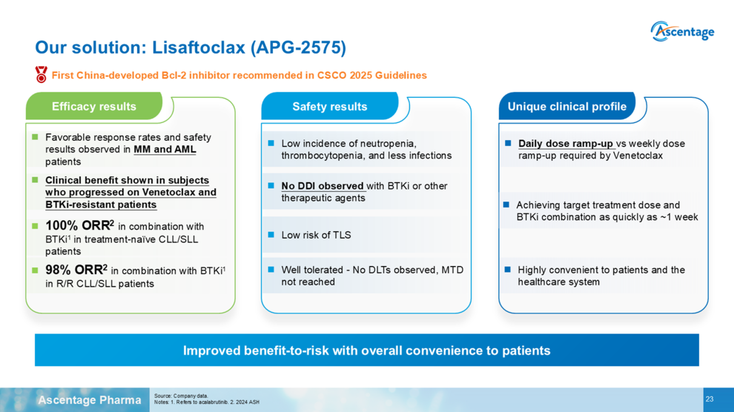
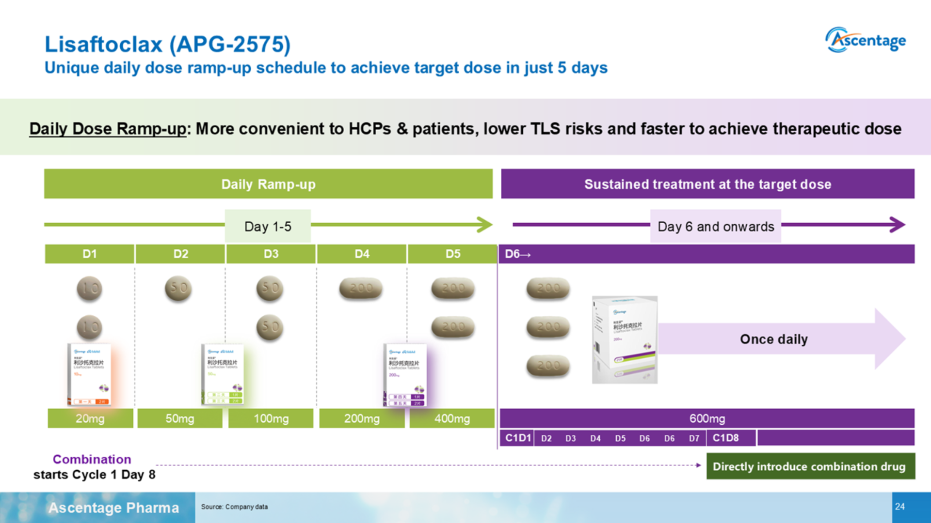
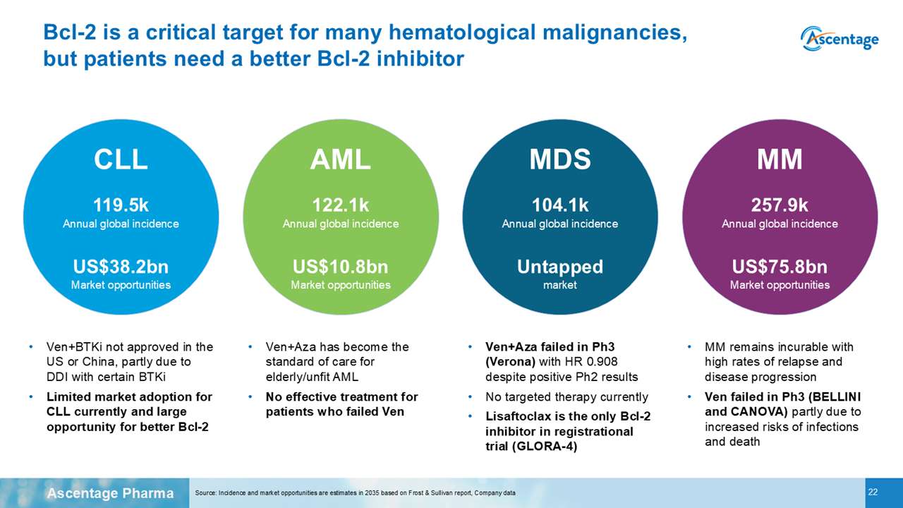

Disclaimer:
This document/email contains competitive intelligence collected via an approved competitive intelligence supplier working on behalf of AbbVie. We collect competitive intelligence consistent with industry standards and AbbVie policy. Not for field distribution. Please reach out to MABI, Legal, or OEC teams with any questions.

